Internship Daily Report - Day 9
Topic: Local File Inclusion (LFI) / IDOR

1. Objective:
To identify and exploit Local File Inclusion (LFI) vulnerability in Mutillidae II lab using Kali Linux.

2. Lab Environment:
Attacker: Kali Linux (192.168.56.101)
Target: OWASP Mutillidae II (192.168.56.102) 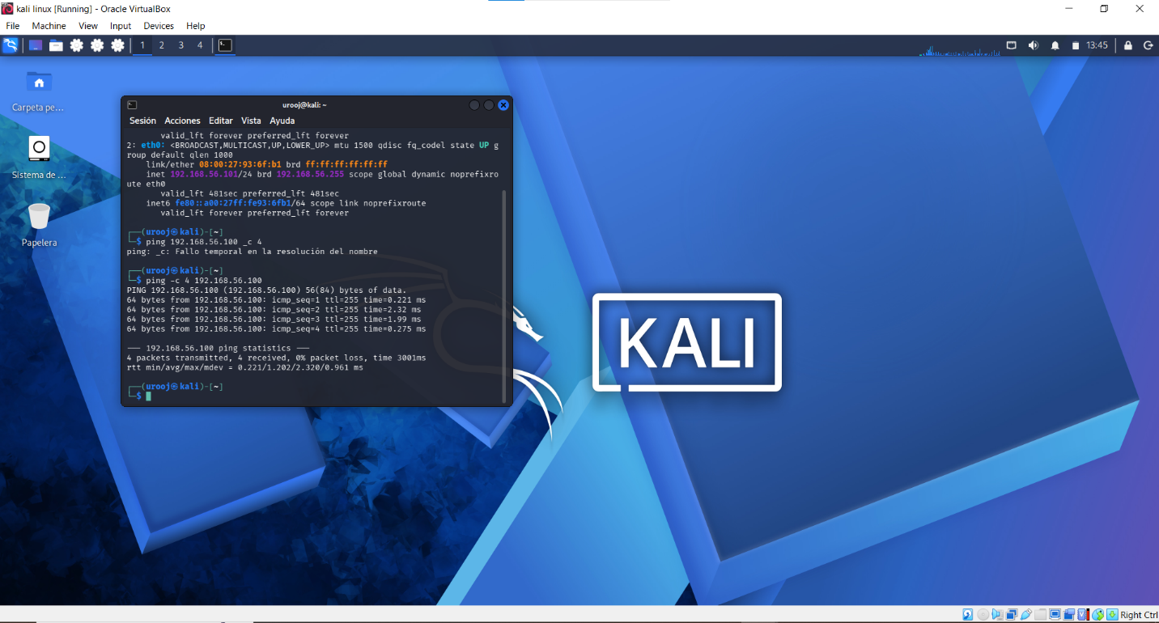
Browser: Firefox ESR
Security Level: 0 (Hosed)

3. Steps Performed:
Step 1: Accessed Mutillidae via http://192.168.56.102/mutillidae
Step 2: Set Security Level to 0 (Hosed)
Step 3: Went to Documentation -> Usage Instructions -> Text File Viewer
Step 4: Found vulnerable parameter: page=text-file-viewer.php
Step 5: Used Payload: http://192.168.56.102/mutillidae/index.php?page=../../../../etc/passwd
Step 6: Successfully read /etc/passwd file showing root:x:0:0:

4. Impact:
Attacker can read sensitive server files, config files, and it can lead to Remote Code Execution.

5. Mitigation:
Use whitelist for file inclusion, validate user input, disable direct file inclusion.

6. Conclusion:
Successfully exploited LFI. Screenshot of /etc/passwd is attached as proof. 

